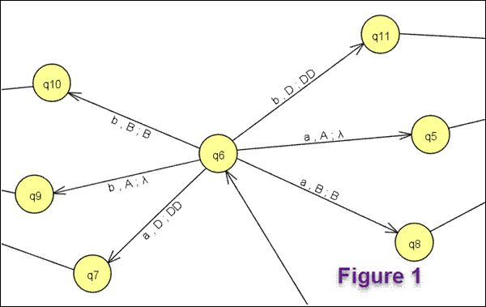

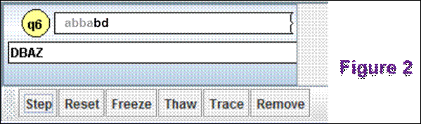

For Figure 2, what will be the STACK part of the trace read after hitting the step button? **DDBAZ**

What state will be listed? **q11**

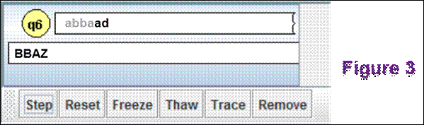

For Figure 3, what will be the STACK part of the trace read after hitting the step button? **BBAZ**

What state will be listed? **q8**

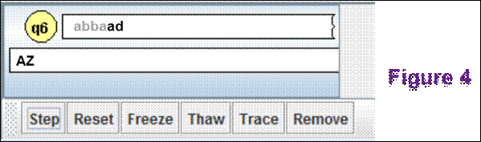

For Figure 4, what will be the STACK part of the trace read after hitting the step button? **Z**

What state will be listed? **Q5**

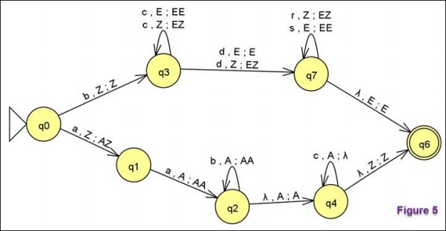

Does it accept the string aacc? **yes**

Does it accept the string aabbcc? **no**

Does it accept the string bcdr? **no**

Does it accept the string bcds? **yes**

Does it accept the string bcccdssss? **yes**

Is the PDA shown in Figure 6 deterministic? **no**

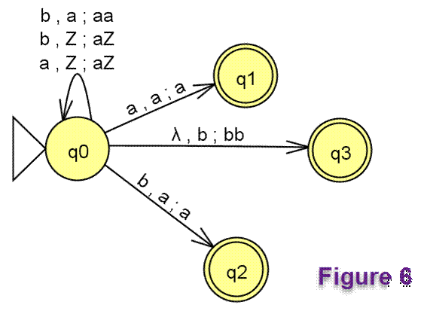

Is the PDA shown in Figure 7 deterministic? **no**

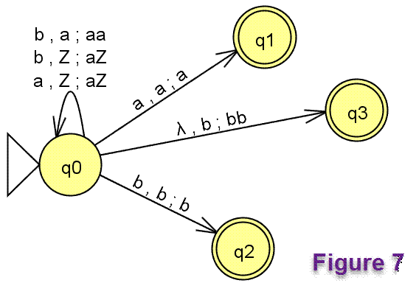

Is the language {a*n*b*m* | *n* and *m* are natural numbers} a regular language? **yes**

Is the language {a*n*b*m* | *n* ≥ 0 and *m* ≥ 5; *n* and *m* are natural numbers} a regular language? **yes**

Is the language {a*n*b*m* | *n* ≥ 0 and *m* ≥ *n*} a regular language? **no**

Is the language {a*n*b*n* | *n* is a natural number} a regular language? **no**